1. Introducing Visual Basic Express


A Brief History of Visual Basic Express

In the mid-1960’s, most computing was done on large computers taking up entire floors of buildings (these machines had less computational power than the laptop I’m typing these notes on!).

Most programming was done in cryptic languages by engineers and mathematicians. Two professors at Dartmouth College wanted to explain programming to “normal” people and developed the BASIC (Beginner’s All-Purpose Symbolic Code) language to help in that endeavor. BASIC was meant to be a simple language with just a few keywords to allow a little math and a little printing.

In the later 1960’s, timeshare computing, where a user could sit at a terminal and interact with the computer, became popular. The primary language used in these interactive sessions was BASIC. The Dartmouth BASIC was not sufficient for the many applications being developed, so many extensions and improvements were made in the BASIC language. Many of the first computer games were written on timeshare terminals using BASIC – gambling games, world simulations and the classic Star Trek game were very popular.

In the mid-1970’s, an issue of Popular Science magazine changed the world of computers forever. On the cover was an Altair computer. About all the computer could do was flash some lights according to a program written by the user. But, it was the first home computer. Two young guys in Seattle, Bill Gates and Paul Allen, saw the potential. They developed a BASIC language for the Altair computer and marketed it through their new company – Microsoft. Yes, the first product sold by Microsoft was the BASIC computer language. It sold for $350 and was distributed on a cassette tape.

When the big wave of “toy” computers – Commodore 64, Texas Instruments 99/4A, Atari 400, Coleco Adam, Timex Sinclair and the IBM PC-Jr. - flooded the market in the early 1980’s, one thing these machines had in common was that they were all programmed in some version of Microsoft’s BASIC. Microsoft’s name for their BASIC language product has changed over the years, having names like GW-BASIC, QuickBasic, QBasic, Visual Basic, Visual Basic .NET, with one of the newest versions being called Visual Basic Express, the language you are about to learn. Visual Basic Express is one of the easiest programming languages to learn. Yet, even though it is easy to learn and to use, Visual Basic Express can also be used to develop very powerful computer programs. Visual Basic Express provides a sophisticated environment for building and testing Windows-based (Windows 7, 2000, Vista or NT) applications.

You’ve used Windows-based applications before. Microsoft’s programs like Word, Excel, Internet Explorer and the windows that appear within these applications (to open and save files, to print files) are all Windows-based applications. These applications are not written in Visual Basic Express (they are written in a language called C++), but they do demonstrate the functionality you can put in your Visual Basic Express applications.

Visual Basic Express can be used to write computer games, businesses can use Visual Basic Express to manage their databases, webmasters can use Visual Basic Express to develop web pages, and people like yourself can use Visual Basic Express to build Windows applications they want and need in their everyday home and work life. In these notes, you will learn how to use Microsoft’s Visual Basic Express to write your own Windows-based applications. You may not become a billionaire like Bill and Paul, but hopefully you’ll have some fun learning a very valuable skill.
Let’s Get Started

Learning how to use Visual Basic Express to write a computer program (like learning anything new) involves many steps, many new terms, and many new skills. We will take it slow, describing each step, term, and skill in detail. Before starting, we assume you know how to do a few things:

- You should know how to start your computer and use the mouse.
- You should have a little knowledge on working with your operating system.
- You should know how to resize and move windows around on the screen.
- You should know how to run an application on your computer by using the Start Menu.
- You should know how to fill in information in Windows that may pop up on the screen.
- You should know about folders and files and how to find them on your computer.
- You should know what file extensions are and how to identify them. For example, in a file named Example.ext, the three letters ext are called the extension.
- You should know how to click on links to read documents and move from page to page in such documents. You do this all the time when you use the Internet.

You have probably used all of these skills if you’ve ever used a word processor, spreadsheet, or any other software on your computer. If you think you lack any of these skills, ask someone for help. They should be able to show you how to do them in just a few minutes. Actually, any time you feel stuck while trying to learn this material, never be afraid to ask someone for help. We were all beginners at one time and people really like helping you learn.

Let’s get going. And, as we said, we’re going to take it slow. In this first class, we will learn how to get Visual Basic Express started on a computer, how to load a program (or project) into Visual Basic Express, how to run the program, how to stop the program, and how to exit from Visual Basic Express. It will be a good introduction to the many new things we will learn in the classes to come.

Starting Visual Basic Express

We assume you have Visual Basic Express installed and operational on your computer. If you don’t, you need to do this first. Again, this might be a good place to ask for someone’s help if you need it. Visual Basic Express is available for free download from Microsoft.

Visual Basic Express is included as a part of Microsoft Visual Studio Express for Windows Desktop (the current version is VS Express for Desktop 2012). Visual Studio Express includes not only Visual Basic Express, but also Visual C++ Express and Visual C# Express. All three languages use the same development environment. Follow this link for complete instructions for downloading and installing Visual Basic Express on your computer:

http://www.kidwaresoftware.com/visbase.htm

Once installed, to start Visual Basic Express:

- Click on the Start button on the Windows task bar.
- Select Programs, then Microsoft Visual Studio 2012 Express
- Then VS Express for Desktop

The Visual Basic Express program should start. Several windows will appear on the screen, with the layout depending on settings within your product.

Upon starting, my screen shows:
Title Bar
Main Menu
Toolbar

Main Window

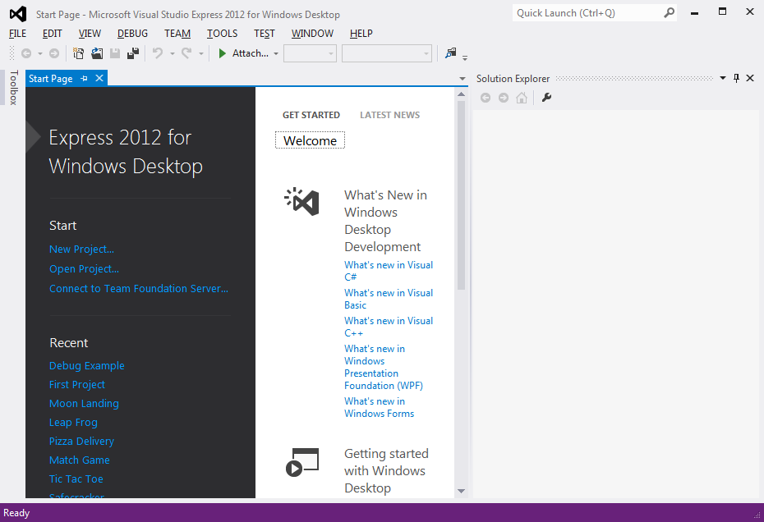
Start Page
Design Window

This screen displays the Visual Basic Express Integrated Development Environment (IDE). This is where we build, run and work with our applications. Let’s point out just a few items on the screen. There are many windows on the screen. At the top of the screen is the Visual Basic Express Main Window. At the top of the main window is the Title Bar. The title bar gives us information about what program we’re using and what Visual Basic Express program we are working with. Below the title bar is the Main Menu from where we can control the Visual Basic Express program. You should be familiar with how menus work from using other programs like word processors and games. Under the main menu is a Toolbar. Here, little buttons with pictures also allow us to control Visual Basic Express, much like the main menu. If you put the mouse cursor over one of these buttons for a second or so, a little ‘tooltip’ will pop up and tell you what that particular button does - try it! Almost all Windows applications (spreadsheets, word processors, games) have toolbars that help us do different tasks. This is the purpose of the Visual Basic Express toolbar. It will help us do most of our tasks. In the middle of the screen is the Start Page, contained in the Design Window. This page shows recent projects you may have worked on and has many helpful topics you might be interested in pursuing as you learn more about Visual Basic Express. – especially note the topics under Get Started.

At any time, your particular screen may look different than ours. The Visual Basic Express environment can be customized to an infinite number of possibilities. This means you can make things look anyway you want them to. You can ‘dock’ windows or ‘float’ windows. You can move windows wherever you want or you can completely delete windows. And, different windows will appear at different times. As you become more experienced with Visual Basic Express, you will learn ways you want things to be. We encourage you to try different things. Try moving windows. Try docking and floating. We won’t talk a lot about how to customize the development environment. (We will, however, always show you how to find the particular window you need.)

Opening a Visual Basic Express Project

What we want to do right now is open a project. Windows applications written using Visual Basic Express are referred to as solutions. A solution is made up of one or more projects. Projects include all the information we need for our computer program. In this course, our applications (solutions) will be made up of a single project. Because of this, we will use the terms application, solution and project interchangeably. Included with these notes are many Visual Basic Express projects you can open and use. Let’s open one now.

We will open a project using the main menu. Follow these steps:

- Select File from the main menu, then click Open Project. An Open Project window will appear:

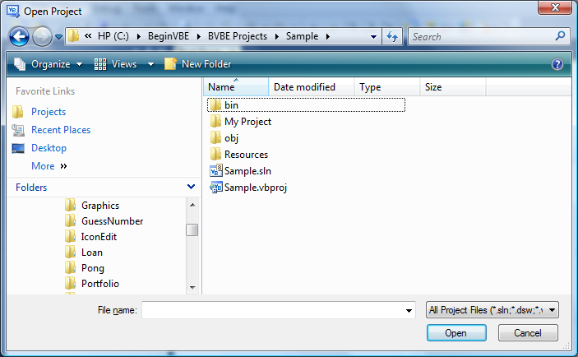
- Find the folder named BeginVBE (stands for Beginning Visual Basic Express). This is the folder that holds the notes and projects for this course. Open that folder.
- Find and open the folder named BVBE Projects. This folder holds all the projects for the course

Remember how you got to this folder. Throughout the course, you will go to this folder to open projects you will need. Open the project folder named Sample.

In this project folder, among other things is a Visual Studio Solution file named Sample and a Visual Basic Express Project file named Sample. Open the Sample solution file (as shown in the example Open Project window). Since there is only one project in this solution, you could also open the project file and get the same results, but it is better to always open the solution file.

Once the project is opened, many windows are now on the screen:

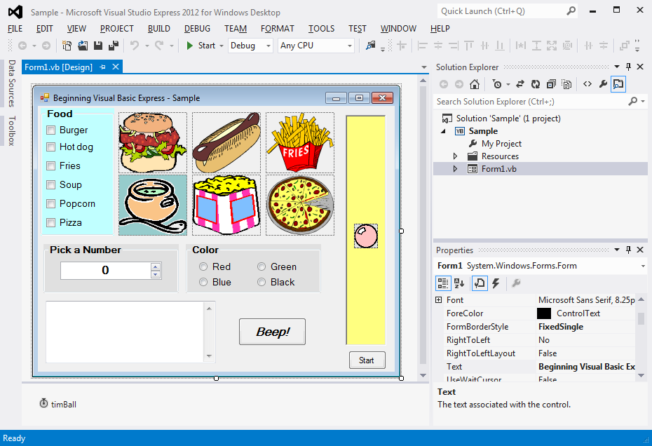

Look for the Solution Explorer window (if it is not there, choose View in the menu and select Solution Explorer). This lists the files in our solution. Right-click the file Form1.vb and choose Open.
In the Design window will appear a window that looks something like this:

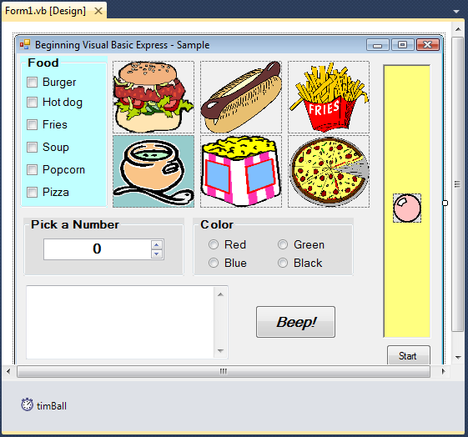

This is our project named Sample. We’re going to spend a bit of time explaining everything that is displayed here. This will introduce you to some of the words, or vocabulary, we use in Visual Basic Express. There are lots of terms used in Visual Basic Express. Don’t try to memorize everything - you’ll see these new words many times through the course.

We call the displayed project window a Form. All Visual Basic Express projects or programs are built using forms. In fact, you have probably noticed that all Windows applications are built using forms of some type. At the top of the form is the Title Bar. It has an icon (little picture) related to the form, a description of what the form does (Beginning Visual Basic Express - Sample), and three smaller buttons that control form appearance (we won’t worry about these buttons right now). There are lots of other things on the form. These other things are the ‘heart’ of a Visual Basic Express computer program.

You see a set of square buttons with food names next to them. You see pictures of food. You see a set of round buttons with color names next to them. There is a little box you can type in with something called a scroll bar on the right side. There’s a big button that says Beep!! There’s a little device for picking the value of a number. And, there’s a ball in a big rectangle with a button that says Start and, below the form, a little thing that looks like a stopwatch. We call all of these other things on the form Controls or Objects. Controls provide an interface, or line of communication, between you (or the user of your program) and the computer. You use the controls to tell the computer certain things. The computer then uses what it is told to determine some results and displays those results back to you through controls. By the way, the form itself is a control. If you’ve used any Windows applications, you’ve seen controls before - you probably just didn’t know they were called controls. As examples, buttons on toolbars are controls, scroll bars to move through word processor documents are controls, menu items are controls, and the buttons you click on when opening and saving files are controls.

I think you get the idea that controls are a very important part of Visual Basic Express, and you’re right. They are the most important part of Visual Basic Express - they are what allow you to build your applications. We will spend much of this course just learning about controls. Right now, though, let’s run this program and get some insight into how a Visual Basic Express project (and its controls) works.
Running a Visual Basic Express Project

After developing a Visual Basic Express project, you want to start or run the program. This gets the program going and lets the user interact with the controls on the form and have the computer do its assigned tasks. We can run a project also using the toolbar under the Visual Basic Express menu. Look for a button that looks like the Play button on a VCR, CD player, or cassette tape player:

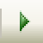
Start Project Toolbar Button

Click this button to run Sample (the project we opened previously).

You can also run a project by: (1) selecting the Debug menu heading, then clicking Start, or (2) pressing the <F5> function key.

The project form will appear and look something like this. Your form may appear slightly different depending on the particular Windows operating system you are using. We use both Windows Vista (seen here) and Windows XP in these notes:

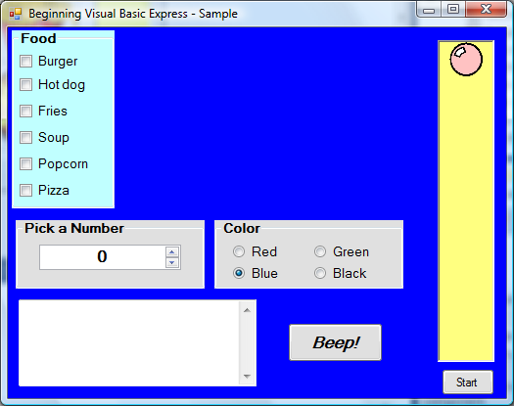

Notice a few things have changed. All the foods have disappeared. The background color of the form is blue. The circle button next to Blue has a black dot in it. The little stopwatch control is not visible. The little ball has moved near the top of the big rectangle. What happened? We’ll find out how and why all this happened as we learn more about Visual Basic Express. Also, notice in the Visual Basic Express title bar (in the main window) that the word Running appears in parentheses next to the project name. It is important to always know if you are running or designing a program – this indication in the title bar will tell you.

The project is now running, but what is it doing? Nothing is happening, or is it? At this point, Visual Basic Express is waiting for you, the user, to do something. We say your Visual Basic Express project is waiting for an event to occur. Nothing can happen in a Visual Basic Express program until an event occurs. We call Visual Basic Express an event-driven programming language. So, let’s cause an event.

An event occurs when you do something on the form - click on something with the mouse, type something in places where words can go, or maybe drag an object across the form. In the upper left corner of the form is a group of six boxes within a rectangular region with the heading Food. Each little box has a food name printed next to it. Click on one of these boxes. Notice what happens. A check appears in the selected box, indicating box selection, and the food named by that box appears on the screen. When we click on a box, we cause an event, called a CheckedChanged event (this means the ‘checked’ status of the box has changed). The computer recognizes the event and does what you have told it to do (through your computer program) if that particular event occurs. In this case, the event tells the computer to display the selected food. Click on the box again. The check mark and the food disappear. You have caused another event and told the computer to make the food disappear. This particular control is called a check box. Notice you can check as many boxes as you want, picking which foods (if any) you want displayed on your screen. Check boxes are used when you want to select items from a list. Two other controls are used in this food example. The rectangular region holding the check boxes is called a group box. The region each food picture is displayed in is called a picture box control. Now, let’s look at causing events with the other controls on the form.

Near the middle of the screen is a group of four round buttons in a group box with the heading Color. Each button has a color name printed next to it. The Blue button has a black dot in it, indicating it is the currently selected color (notice the form is blue). Click on another of these buttons. Notice what happens. The form color changes to the selected color. This CheckedChanged (meaning the ‘checked’ or actually ‘dotted’ status of the button has changed) event tells the computer to change the form background color. Notice that when you select a new color, the black dot appears in the selected button and disappears in the previously selected button. Unlike the check boxes we saw earlier, you can only select one of these buttons. This makes sense - the form can only be one color! These round buttons are called radio buttons. Radio buttons are used when you need to choose exactly one option from a list of many. They are called radio buttons because, on a radio, you can only choose one option (station) at a time.

Under the Food group box is another group box with the heading Pick a Number. There we see a control called a numeric up-down control. There is a label area displaying a number and next to the number is another control with one arrow pointing up and one pointing down (a scroll bar). You’ve probably seen scroll bars in other applications you have used. The scroll bar is used to change the displayed number. Click on the arrow on the top of the scroll bar. The displayed value will increase by 1. Continued clicking on that arrow will continue to increase the value. Clicking the lower arrow will decrease the value. In this example, the computer is responding to the numeric up-down control’s ValueChanged event, which occurs each time an arrow is clicked, changing the displayed value.

Under the Pick a Number group box is a region with a scroll bar on the right side. This control is called a text box. You can click in it, then type in any text you want. Try it. The text box is like a little word processor in itself. Each time you type something in the text box, several events occur. There is a KeyPress event when you press a key and a Change event that is called each time the text in the box changes.

Next to the text box is a button that says Beep!! Click the button and you should hear a beep on your computer’s speaker. This control is called a button and is one of the most widely used controls in Visual Basic Express. The Click event told the computer to make the speaker beep.

The last thing on our form is a tall, yellow, rectangular control called a panel that contains a picture box control displaying a ball. Under the panel is a button that says Start. Click on that button, that is, cause a Click event. The ball starts moving down. It continues moving down until it hits the bottom of the panel, then starts moving back up. It will continue to do this until you click the button that now says Stop. Remember the little stopwatch that was below our form in design mode, but disappeared when we ran the project. It is being used by the bouncing ball example - it is called a timer control. The Click event on the button, in addition to changing what the button says to Stop, also started this timer control. The timer control generates Tick events all by itself at preset time intervals. In this example, a Tick event is generated every 1/10th of a second and, in that event, the ball position is changed to give the appearance of movement. Notice that even while the ball is bouncing, you can change the form color, make toys appear and disappear, type text, and make the computer beep. So, Visual Basic Express even has the capability of handling multiple events.

Obviously, this project doesn’t do much more than demonstrate what can be done with Visual Basic Express, but that is a important concept. It points out what you will be doing in building your own Visual Basic Express projects. A project is made up of the controls that let the user provide information to the computer. By causing events with these controls, the computer will generate any required results. We haven’t worried about how to use the events to determine these results, but we will in all the later classes. By the time you have finished this course, you will be able to build projects that do everything (and more) that the Sample project does. Let’s look now at how to stop the project.
Stopping a Visual Basic Express Project

There are many ways to stop a Visual Basic Express project. We will use the toolbar. Look for a button that looks like the Stop button on a VCR, CD player, or cassette tape player (you may have to move the project form down a bit on the screen to see the toolbar):
Stop Project Toolbar Button


- Click on this button (you may have to click it twice). The project will stop and Visual Basic Express will return to design mode.

Alternate ways to stop a project are:

- Selecting the Debug menu heading, then clicking Stop Debugging
- Click the Close button found on the form. It is the little button that looks like an X in the upper right corner of the form.

Stopping Visual Basic Express

When you are done working with a Visual Basic Express project, you want to leave the Visual Basic Express program and the design environment. It is the same procedure used by nearly all Windows applications:

- Select File in the main menu.
- Select Exit (at the end of the File menu).

Stop Visual Basic Express now. Visual Basic Express will close all open windows and you will be returned to the Windows desktop. In stopping Visual Basic Express with Sample active, you may be asked if you want to save certain files. Answer No. Like with stopping a project, an alternate way to stop Visual Basic Express is to click on the close button in the upper right hand corner of the main window. It’s the button that looks like an X.

Summary

We covered a lot of new material here. As we said earlier, you learned a lot of new words and concepts. Don’t worry if you don’t remember everything we talked about here. You will see the material many times again. It’s important that you just have some concept of what goes into a Visual Basic Express project and how it works. And you know how to start and stop Visual Basic Express itself.

In summary, we saw that a Visual Basic Express project is built upon a form. Controls (also called objects) are placed on the form that allow the user and computer to interact. The user generates events with the controls that allow the computer to do its job. In the next class, you will begin to acquire the skills that will allow you to begin building your own Visual Basic Express projects. You will see how the parts of a project fit together. Using project Sample as an example, you will learn how to locate important parts of a project. Then, in Class 3, you will actually build your first project!

This page intentionally not left blank.

